Resilience for Dairy (R4D) has received funding from the European Union’s Horizon 2020 research and innovation programme under grant agreement N°101000770
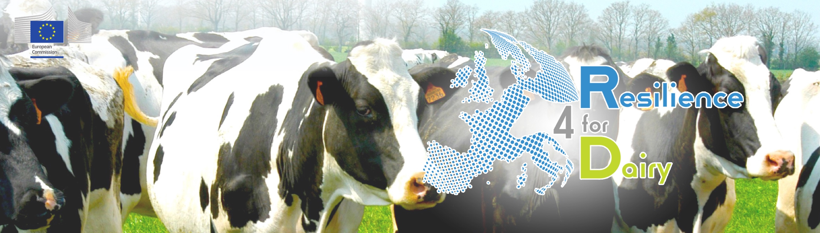

Dear Participant,

We are excited to send you a special invitation to participate in a series of four insightful webinars on Lean Management in dairy farming. These webinars are designed to help you enhance productivity, reduce waste, and ultimately improve your farm's profitability.

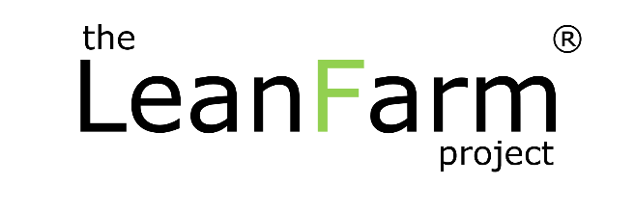
Our expert presenter, Jana Hocken, with her extensive experience in applying LEAN principles, will guide you through essential concepts that can improve your dairy farm operations. With a solid foundation as an engineer with Toyota, Jana Hocken brings more than 20 years of experience practicing, leading, teaching and implementing lean and continuous improvement culture and methodologies into companies globally. She has successfully helped hundreds of companies across Europe, America, Asia and Australia, apply lean thinking to improve their operations. Jana has worked across most industry sectors including automotive, rail, aerospace, defence, healthcare, government, finance, IT and agriculture. Since 2017 Jana has helped to bring lean concepts to farming, first implementing lean on her family’s 1,000 cow dairy farm in New Zealand. With proven results, she founded The LeanFarm Project to help create awareness of the significant benefits lean has in farming. Jana has now delivered LeanFarm workshops and speaking events to thousands of farmers across the world, helping them to start their lean journeys. In 2019 she published her book ‘The Lean Dairy Farm’ – a highly practical and relevant step by step guide that every farmer can use to apply lean principles on farm.

Here are the details for each webinar:

WEBINAR 1: Introduction to Lean Thinking
- Date: November 20, 2023
- Time: 08:00 PM Brussels
- Topic: The LeanFarm Project: Webinar 1 - Introduction to Lean Thinking
- Description:
Join us for this interactive webinar to learn about Lean in dairy farming and how this proven management methodology can help your farm to improve its productivity, reduce waste and costs, build a high performing team and culture and achieve better results and profitability. The webinar will include a short Q&A session at the end so that farmers will have the opportunity to ask questions directly.
- Register Here

WEBINAR 2: The 8 Wastes on Farm
- Date: November 27, 2023
- Time: 08:00 PM Brussels
- Topic: The LeanFarm Project: Webinar 2 - The 8 Wastes on Farm
- Description:
Join us for this interactive webinar to learn about the 8 Wastes that exist in your farm business and how to identify and eliminate this waste to reduce your costs and improve productivity and profitability. The webinar will conclude with a Q&A session to give farmers an opportunity to ask questions directly.
- Register Here

WEBINAR 3: Visual Management on Farm
- Date: December 4, 2023
- Time: 08:00 PM Brussels
- Topic: The LeanFarm Project: Webinar 3 - Visual Management on Farm
- Description:
Join us for this interactive webinar to learn about the power of visual management and visualisation on your farm. You will discover how to visualise your farm’s and team’s critical information and data to improve communication, decision making, and drive actions. This lean tool can transform your farm team and performance. The webinar will include a short Q&A session at the end so that farmers will have the opportunity to ask questions directly.
- Register Here

WEBINAR 4: Standard Work on Farm
- Date: December 11, 2023
- Time: 08:00 PM Brussels
- Topic: The LeanFarm Project: Webinar 4 - Standard Work on Farm
- Description:
Join us for this interactive webinar to learn about the importance of systems, processes and standards on farm to produce a high quality product at the lowest cost, efficiently and effectively, reduce waste, improve team ownership and accountability and create consistent, reliable outcomes. The webinar will include a short Q&A session at the end so that farmers will have the opportunity to ask questions directly.
- Register Here

Don't miss this opportunity to gain valuable insights and guidance from lean dairy farm expert. Each webinar will also include a Q&A session, allowing you to ask questions and engage with Jana directly. To register for any of these webinars, simply click on the provided registration links, and you will receive a confirmation email with further details about joining the webinar.

We look forward to your participation in these informative sessions, which we believe will bring positive change to your dairy farm. Feel free to share this invitation with other dairy farmers who might benefit from this knowledge. Should you have any questions or require further information, please don't hesitate to contact us.

